Dokumentasi Proyek: JT.07 - JT.08

Designator: SLACK SUPPORT POLE
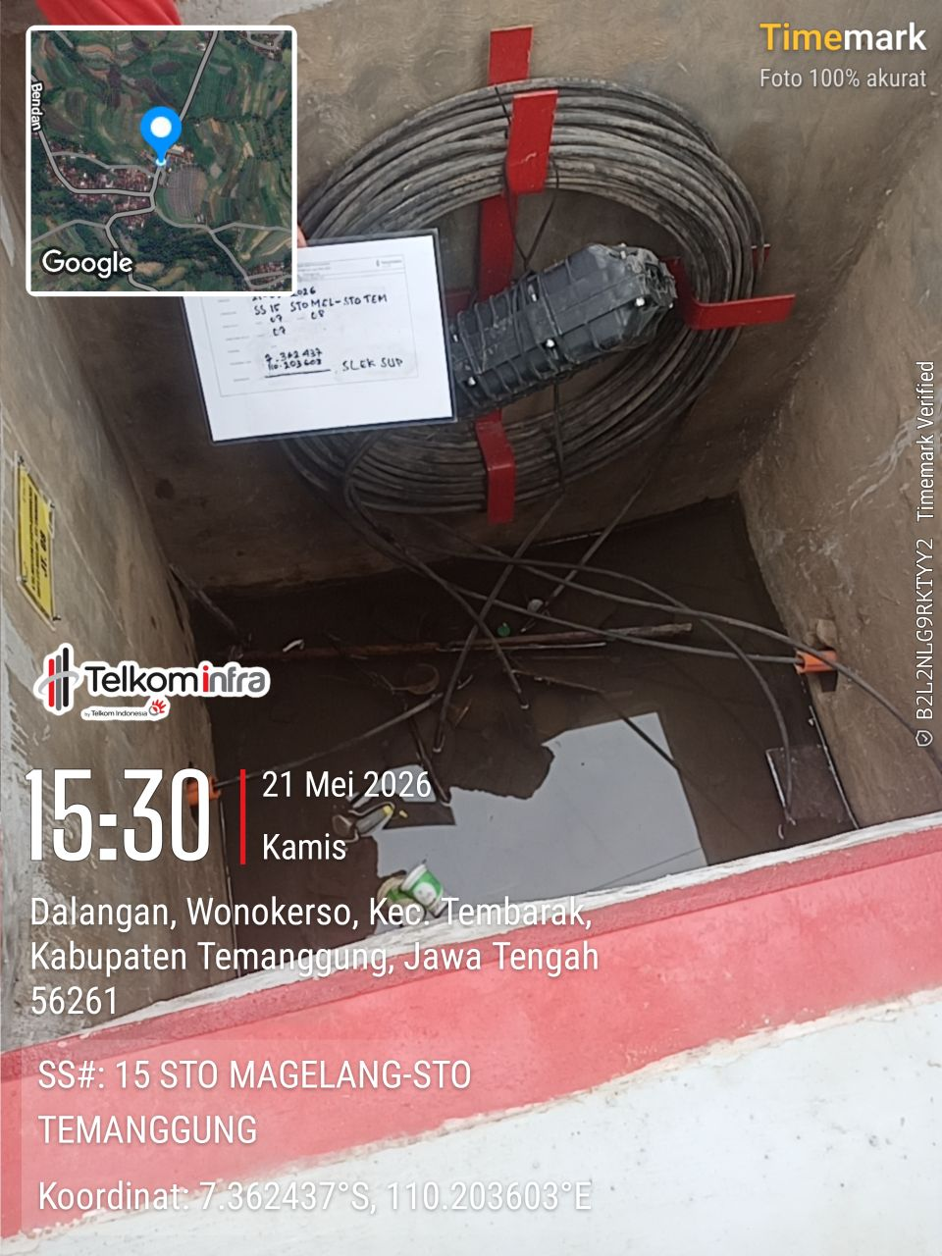 | 